《AI懂我-心智障碍者动态支持档案》开发关键步骤截图和session ID
- 重新设计(期间过程崩溃了两次，这是第三次重新开始)
2965860309021466:1cf5de337efe2e6c5ed6910ef9024e1d_6a4f3fc5a868df99e4823de4.6a4f3fc6a868df99e4823de7.6a4f3fc5a868df99e4823de5:TRAE Work CN.0.1.30.no_sid.no_ppe.T(2026/7/9 14:29:26)
- 对话式采集
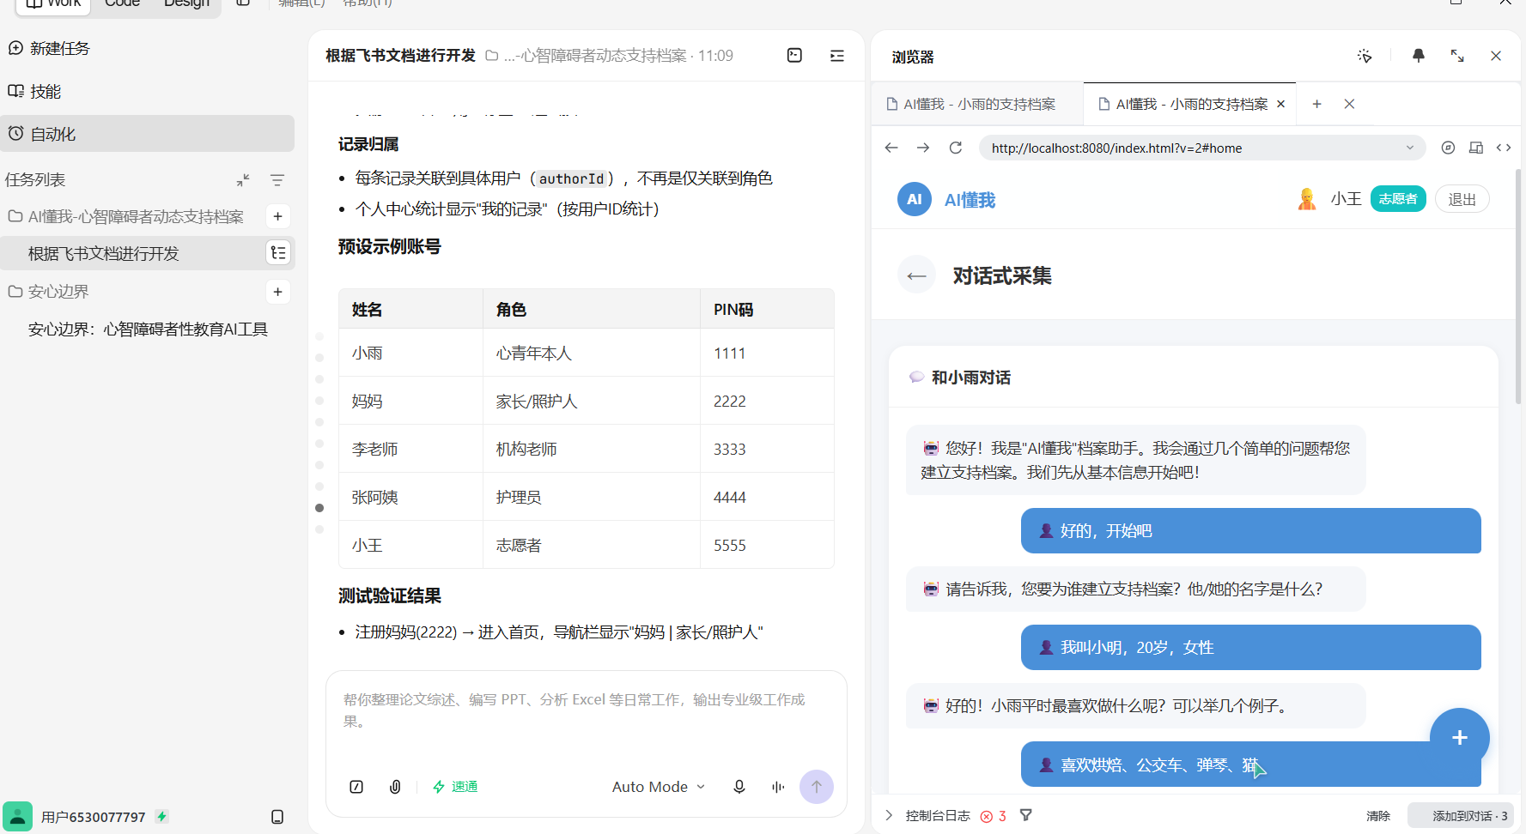
2965860309021466:8ef1aaa549e288fdb0cb727160162198_6a4f3fc5a868df99e4823de4.6a506566877219a451989b92.6a506565877219a451989b90:TRAE Work CN.0.1.32.no_sid.no_ppe.T(2026/7/10 11:22:14)
- 多角色登陆
2965860309021466:160b577aa53acc5988d547bb4e91669a_6a4f3fc5a868df99e4823de4.6a506d45877219a451989bfe.6a506d44877219a451989bfc:TRAE Work CN.0.1.32.no_sid.no_ppe.T(2026/7/10 11:55:49)
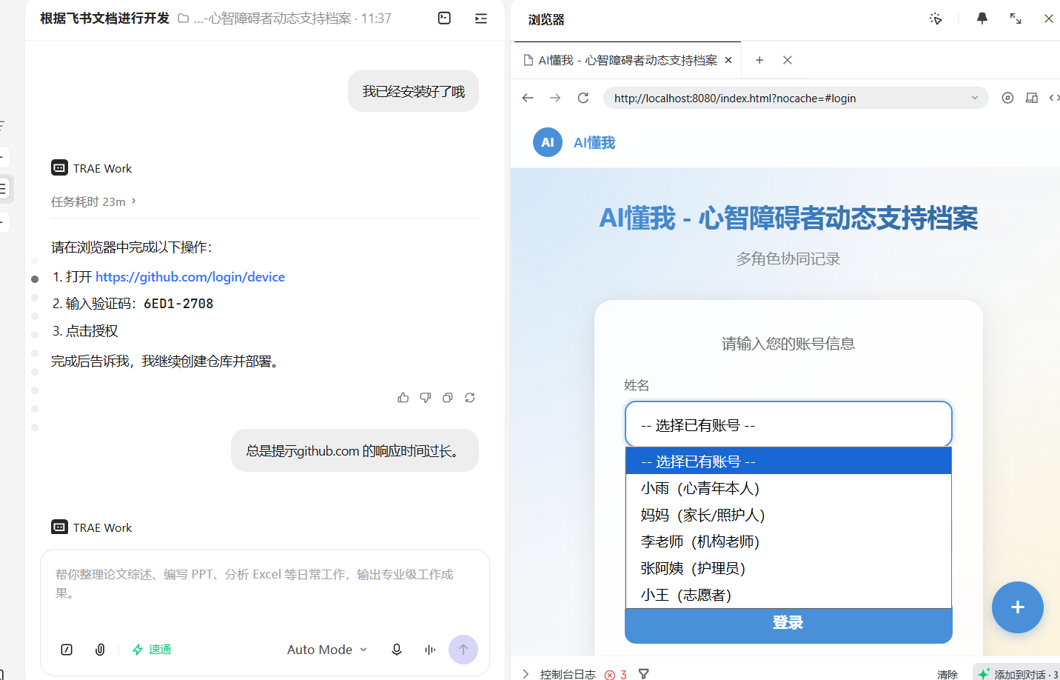
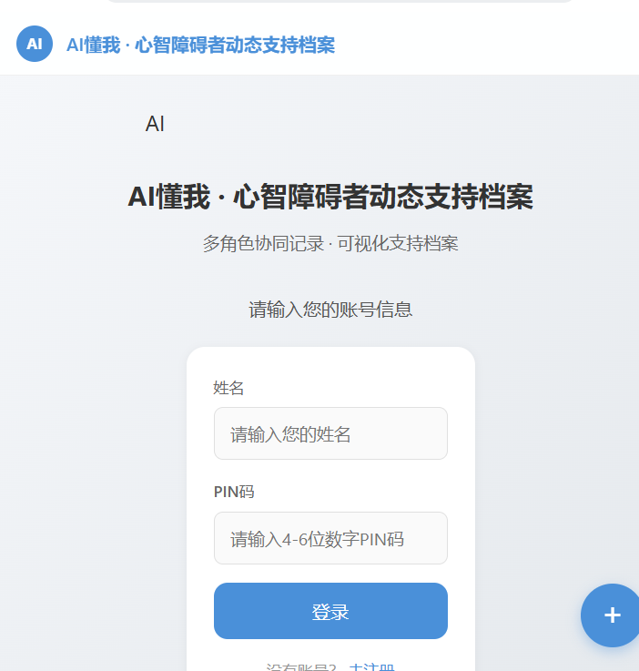
- 进行自我修改（失败并崩溃了，到这一步，我只能重新开始）
2965860309021466:13a9ab129c6955fe687daa51eea586a6_6a4f3fc5a868df99e4823de4.6a507483877219a451989c42.6a507482877219a451989c40:TRAE Work CN.0.1.32.no_sid.no_ppe.T(2026/7/10 12:26:43)
5.重新更新四大功能
2965860309021466:89fcbe660522196b78c4a37efffa49b1_6a4f3fc5a868df99e4823de4.6a519c59f9a3fa32e816f1b5.6a519c59f9a3fa32e816f1b3:TRAE Work CN.0.1.32.no_sid.no_ppe.T(2026/7/11 09:28:57)
